Infosys Springboard Virtual Internship 6.0 Completion Report

Team Details <Do not mention any personally identifiable information like email ID, institute details, mobile phone number etc.>

Batch Number: 8 – NeuroFleetX (Smart Bus Fleet Management System)
Start date : 05-11-2025
Names:
- M Saisree
- Hansika Gurjar
- Prashant Khandeker
Internship Duration: 8 Weeks

1. Project Title
NeuroFleetX – Smart Bus Fleet Management System

2. Project Objective

NeuroFleetX is a smart bus fleet management platform designed to modernize public and private transportation systems through real-time monitoring, efficient bus operations, and improved passenger experience. The objective of the project is to provide a complete digital solution that supports fleet administrators, drivers, and passengers with features such as secure authentication, bus and route management, seat booking, live bus tracking, alert handling, and analytics.By using a full-stack architecture (React frontend, Spring Boot backend, MongoDB database), NeuroFleetX enables:

centralized fleet control for admins,

simplified trip management for drivers, and

real-time tracking and booking support for passengers.

Ultimately, NeuroFleetX aims to reduce manual work in fleet operations, enhance safety, improve punctuality, and deliver a smart transportation experience.

3. Project description in detail
NeuroFleetX is a full-stack Smart Bus Fleet Management System developed to improve transportation operations through real-time fleet monitoring, efficient route handling, and a better passenger travel experience. The project focuses on digitalizing core bus management tasks such as bus and route scheduling, ticket booking, live location tracking, seat availability monitoring, and alert handling. It is designed for multiple stakeholders including passengers, drivers, and administrators, enabling smooth coordination and better decision-making in day-to-day fleet operations.
The system is built using a modern full-stack architecture: React.js for the frontend, Java Spring Boot for backend REST API development, and MongoDB for database storage. NeuroFleetX provides secure role-based authentication for passengers, drivers, and admins. Administrators can manage buses, routes, stops, and driver assignments, while passengers can view buses on routes, check seat availability, book tickets, and track buses in real time. Drivers are supported with operational updates and tracking-related functions.
A key highlight of NeuroFleetX is Live Bus Tracking, where bus location updates are continuously collected and stored, and real-time updates are delivered to users through tracking APIs and live updates. The system also maintains structured collections for buses, routes, stops, tickets, seat status, tracking updates, and alerts for effective handling of fleet operations. Additionally, NeuroFleetX includes a reporting module where admins can analyze operational data such as bookings, seat occupancy, route usage trends, and emergency/alert history, helping improve fleet efficiency.
Overall, NeuroFleetX acts as a smart digital platform for transportation management by combining real-time tracking, booking automation, and centralized admin monitoring. The project aims to reduce manual workload, enhance passenger convenience, increase fleet visibility, and support safe and efficient bus operations through a scalable and user-friendly system.
4. Timeline Overview
Week | Activities Planned | Activities Completed
Week 1 | Requirement gathering, project scope definition, module planning, team role allocation | Requirements finalized, scope documented, roles assigned, initial feature list prepared (auth, buses, routes, tracking, booking).
Week 2 | Research & finalize tech stack, create system architecture, setup repository | Tech stack finalized (React + Spring Boot + MongoDB), GitHub repo created, system architecture flow planned.
Week 3 | Database design and backend skeleton setup (Spring Boot project structure) | MongoDB collections/schema design (Users, Buses, Routes, Stops, Tickets, Tracking, Alerts), backend project initialized.
Week 4 | Backend development – Authentication and role-based access, user module | Implemented signup/login with JWT, role-based access for Passenger/Driver/Admin, initial API testing done.
Week 5 | Backend development – Bus management, Route & Stop APIs | Developed APIs for bus CRUD, route creation, stop management, validation added, integrated MongoDB using Spring Data.
Week 6 | Frontend development – UI pages, navigation, dashboard integration | Built React pages: landing, login/signup, dashboard, bus listing, route views; connected frontend with backend APIs
Week 7 | Integration – Ticket booking, seat availability, live tracking, alerts module | Implemented ticket booking flow, seat status updates, tracking APIs, alerts/emergency reporting; end-to-end integration completed
Week 8 | Testing, debugging, documentation, final deployment | Completed functional testing, fixed integration bugs, prepared documentation & user guide, deployed full-stack project successfully.

5a. Key Milestones
Milestone | Description | Date Achieved
Project Kickoff | Project kickoff defined objectives, scope, and roles. | 05 – Nov - 2025
Prototype/First Draft | Developed the prototype for resume matching and skill recommendation. | 20 - Nov - 2025
Mid-Term Review | Completed mid-term review to assess progress and refine project approach. | 05 - Dec - 2025
Final Submission | Submitted the completed Budgetwise project with full functionality and documentation. | 20 - Dec - 2025
Presentation | Prepared and delivered the project presentation showcasing features and outcomes. | 05 - Jan - 2026

5b. Project execution details
- Requirement Analysis – Collected requirements for fleet management, passenger booking, admin control and live tracking; finalized project goals and modules.
- Technology Selection – Selected React.js for frontend, Java Spring Boot for backend APIs, and MongoDB for database to ensure scalability and fast development.
- Database Design (MongoDB) – Created collections for Users, Buses, Routes, Stops, Tickets/Bookings, Seat status, Live Tracking updates, Alerts and Reports.
- Backend Development (Spring Boot APIs) – Developed REST APIs with validation, exception handling and clean layered architecture (Controller → Service → Repository).
- Authentication & Authorization – Implemented login/signup with JWT token-based security and role-based access for Admin, Driver, Passenger.
- Booking & Seat Management – Implemented ticket booking system, automatic seat availability updates, and booking history tracking for passengers.
- Live Tracking Module – Implemented live location tracking APIs for buses and enabled real-time monitoring of bus location for users/admin.
- Alerts & Emergency Handling – Added alert generation module for emergency reporting and storing event logs for monitoring and safety.
- Frontend Development (React UI) – Developed responsive UI screens such as landing page, login/signup, dashboards, booking screens, tracking view and report screens.
- System Integration – Connected frontend with backend APIs and integrated MongoDB for complete end-to-end working functionality.
- Testing & Debugging – Performed unit testing, API testing (Postman), integration testing, fixed bugs and improved stability.
- Deployment & Documentation – Completed documentation and user guide, packaged final deliverables, and deployed the project successfully.

6. Snapshots / Screenshots
Step 1 : Go to Github and clone the Repository in your system then open in VS Code to do the execution , here is the github repo link : https://github.com/saisree2905/NeuroFleetx-Final
Step 2 : Start the frontend with CMD
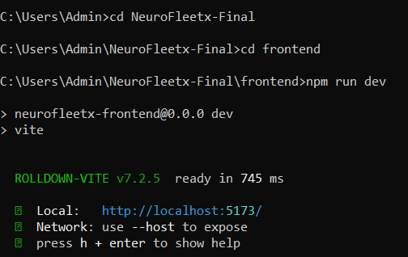
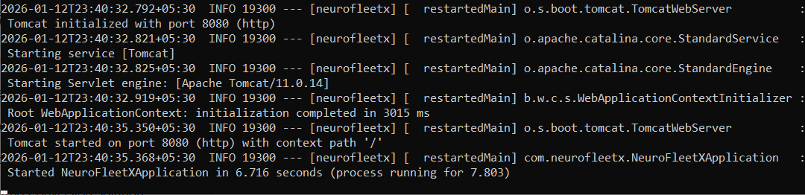
Step 3: Here is the Landing page with basic navigation and a chatbot for helping user
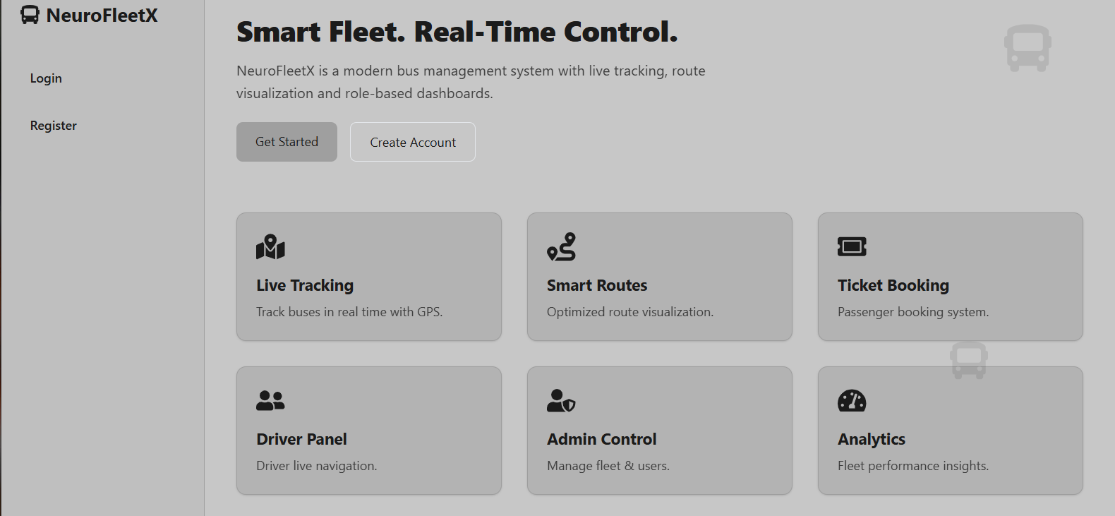
Step 4: After clicking on Login/Signup here user need to register and log in for Authentication.
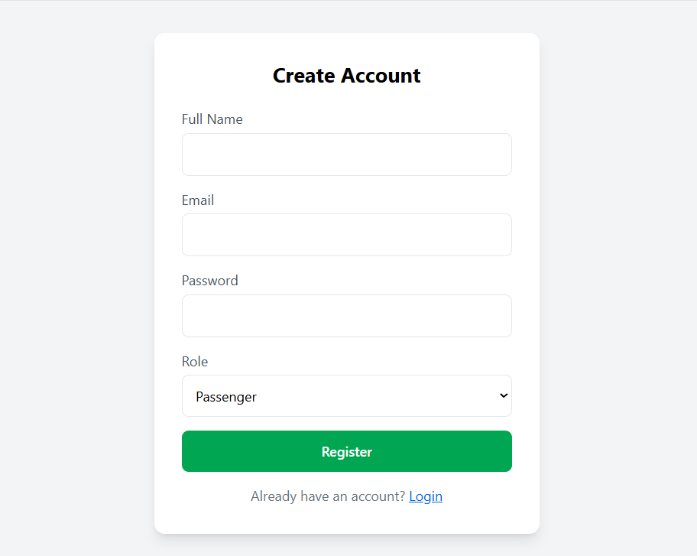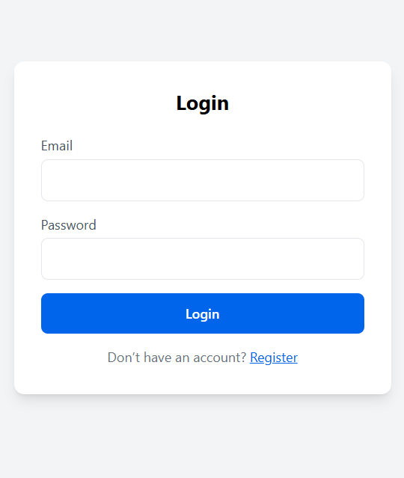
Step 5: Passenger Dashboard
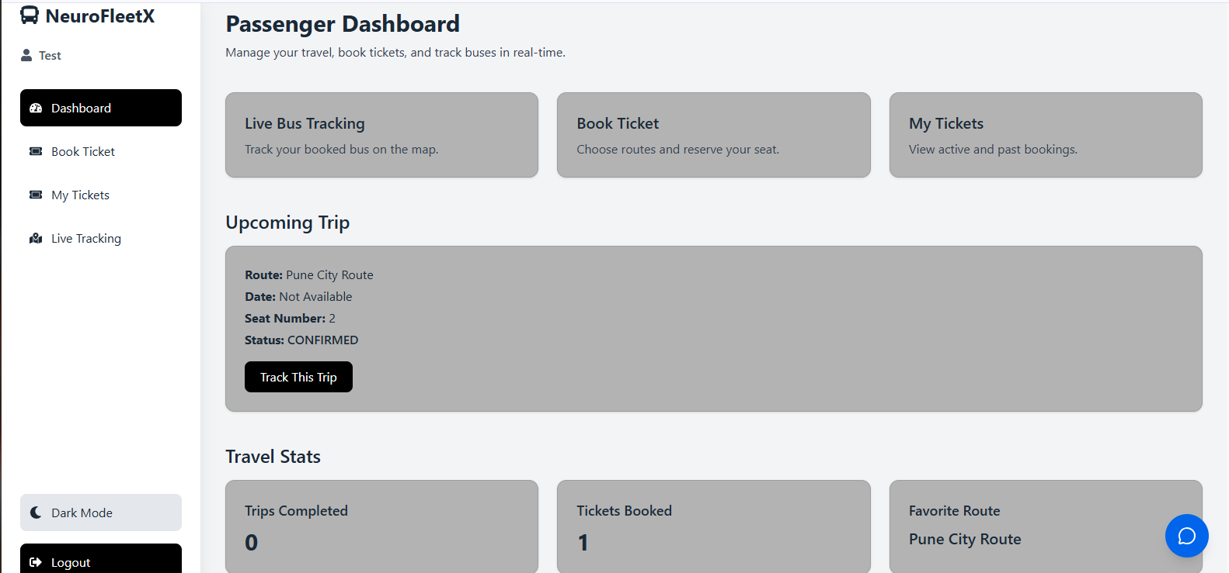
Step 6: After Login the User can Book a Ticket.
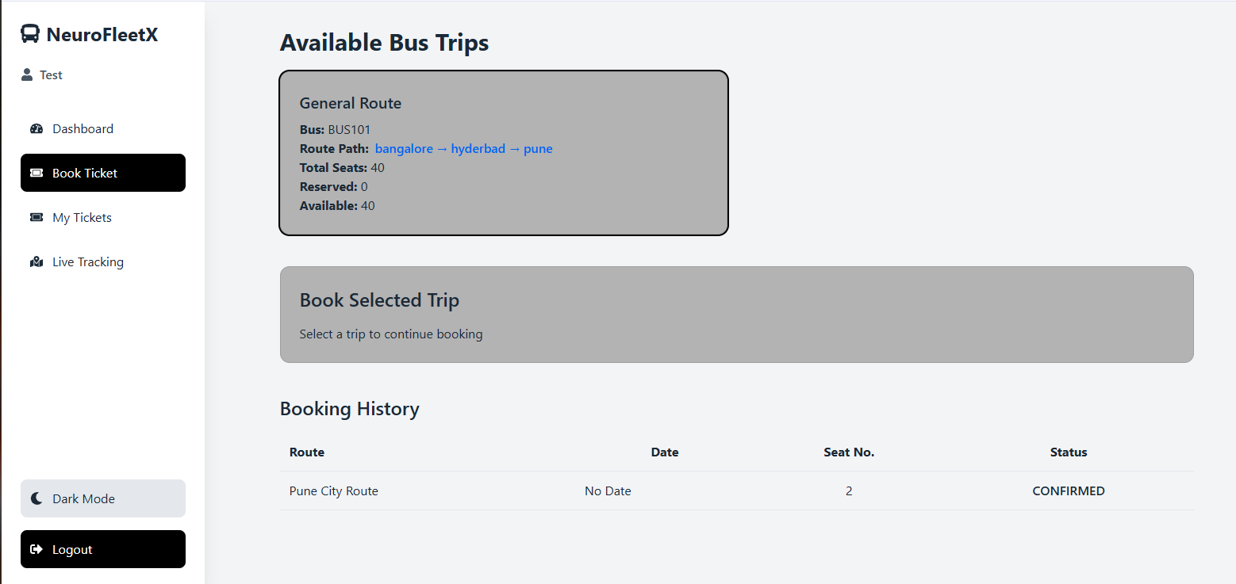
Step 7: This is the My Tickets Section for the Users.
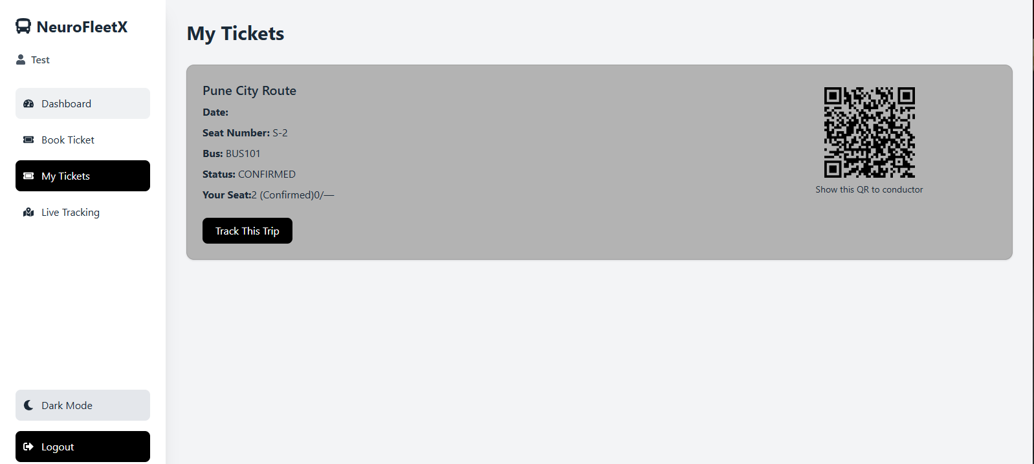
Step 8: Admin Dashboard
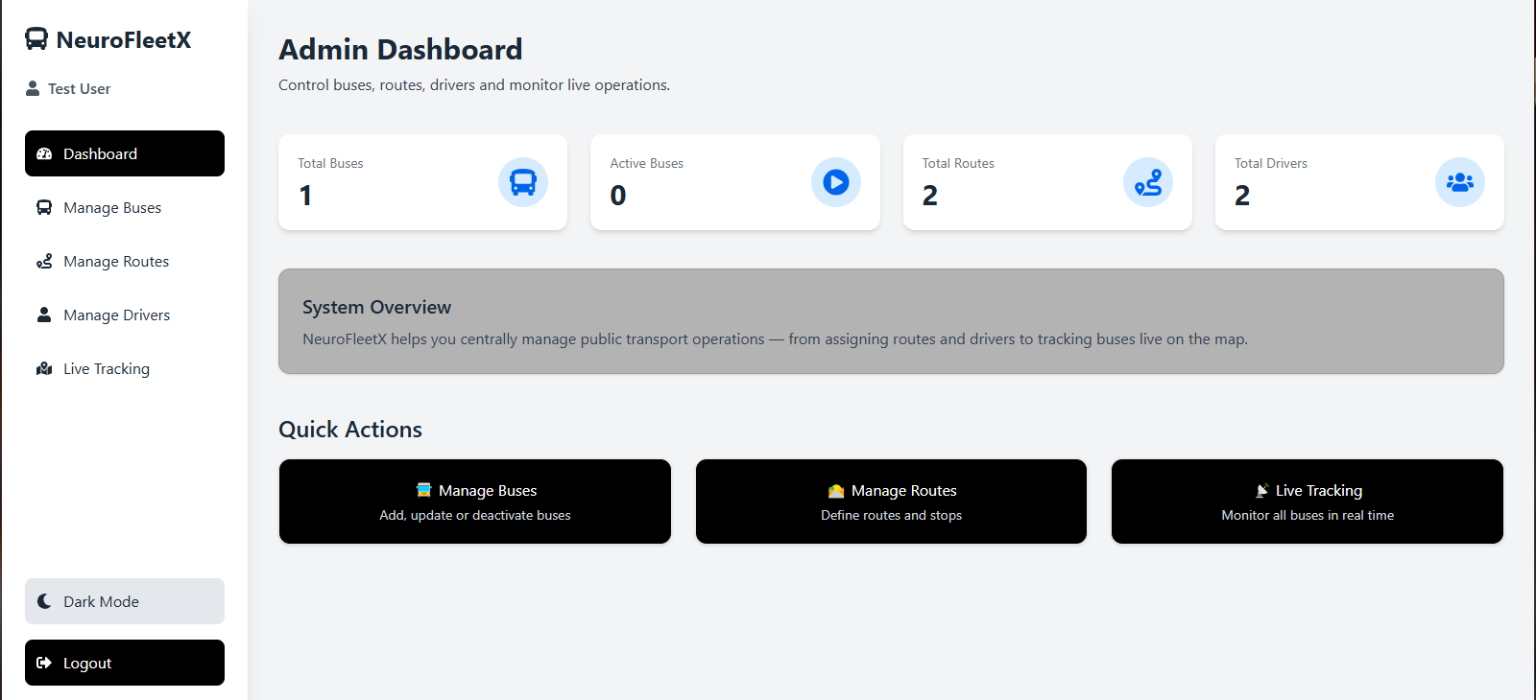
Step 9: Add Buses Section for Admin
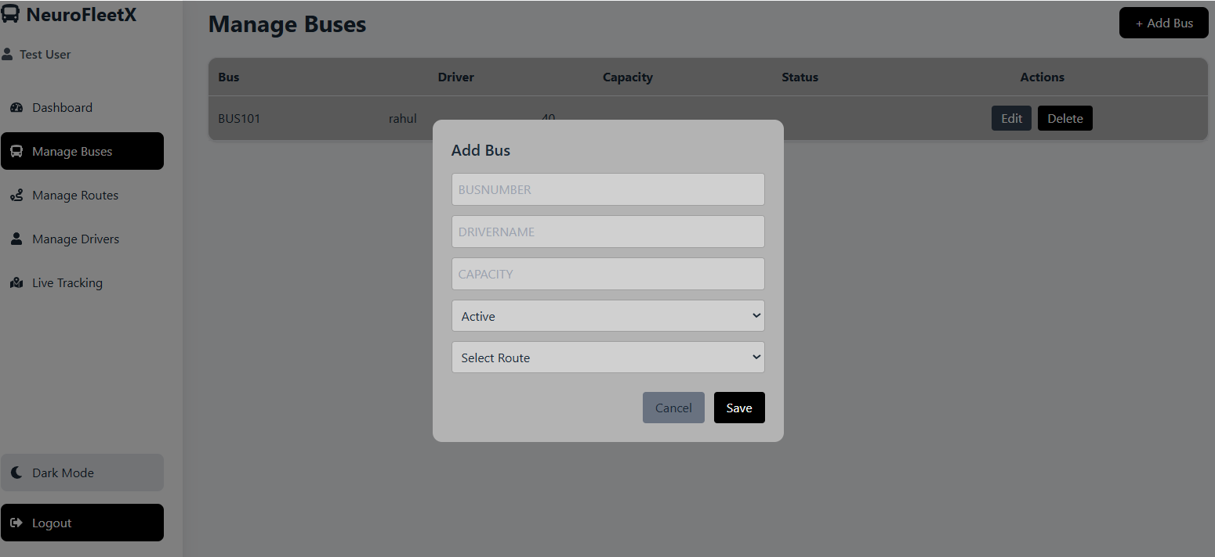
Step 10: Add or Manage Routes section
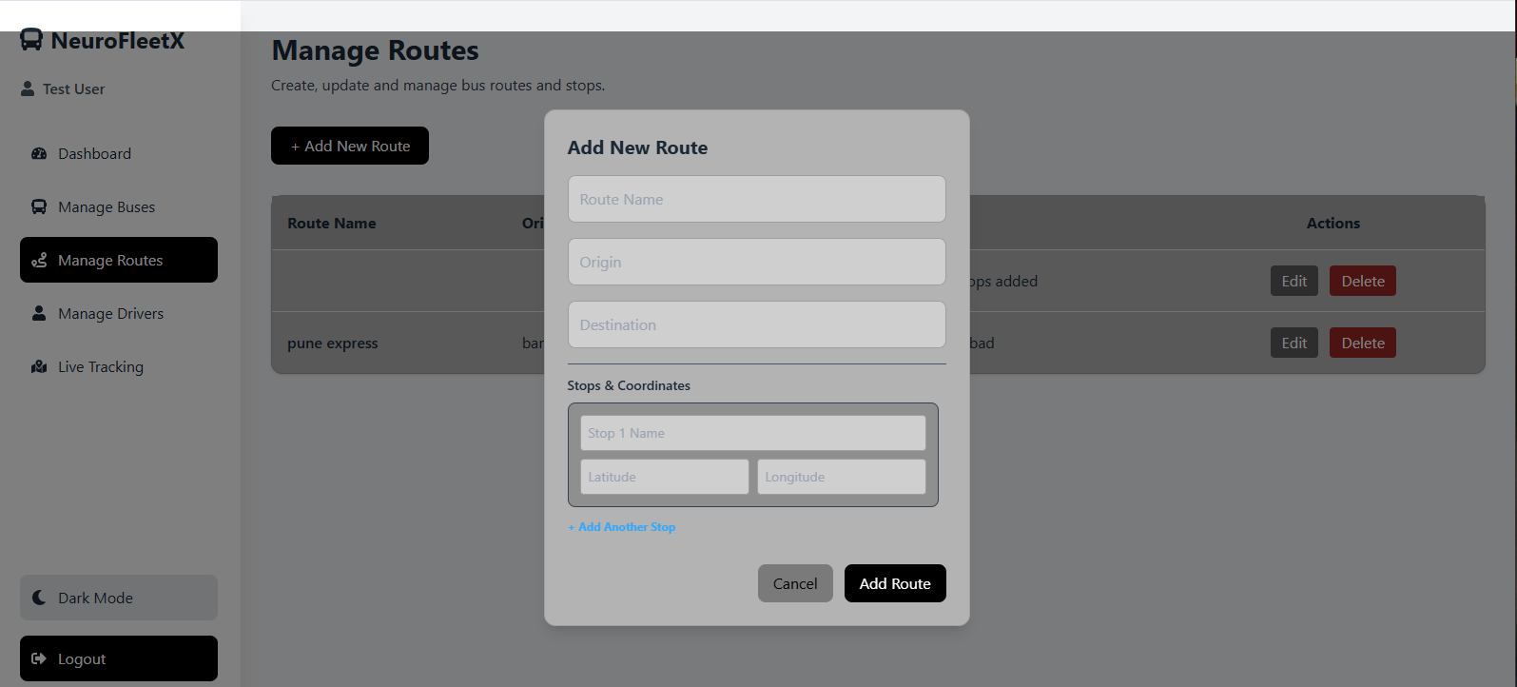
Step 11: Manage Drivers Section by Admin
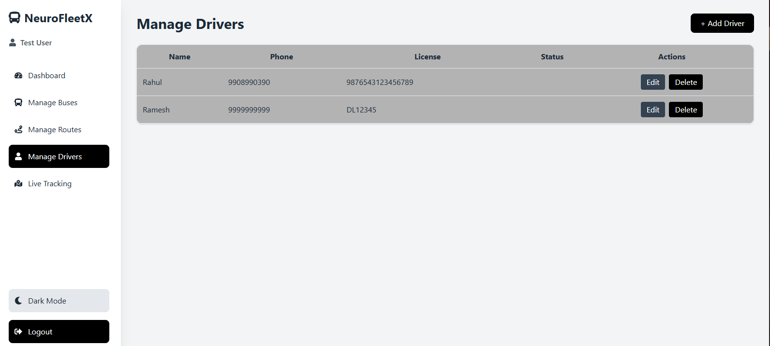
Step 12: Live Tracking System
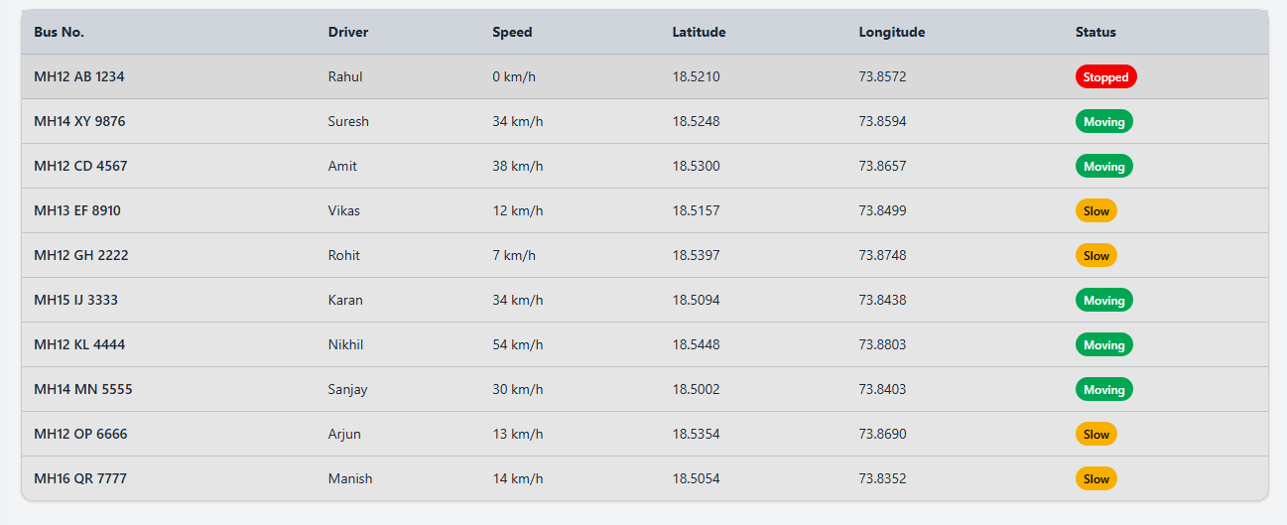
End : Using Chatbot user can communicate with Chatbot
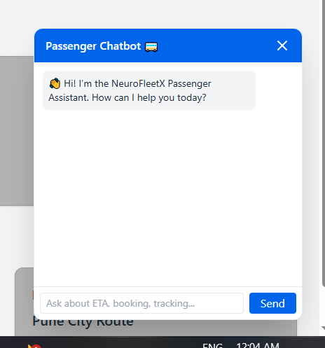

7. Challenges Faced
- Real-Time Tracking Implementation – Implementing live tracking for buses required careful handling of continuous location updates and ensuring smooth real-time display on the UI.
- Backend–Frontend Integration – Connecting React (Vite) frontend with Spring Boot REST APIs involved multiple CORS and request mapping issues during integration.
- Database Design Complexity (MongoDB) – Designing collections for buses, routes, stops, tickets, seat status, tracking and alerts was complex and required multiple revisions to ensure proper relationships.
- Authentication & Role Management – Implementing secure authentication with JWT and managing permissions for multiple roles (Admin/Driver/Passenger) was challenging.
- Seat Availability Handling – Maintaining real-time seat availability during booking required proper validation to avoid duplicate bookings and inconsistent seat data.
- Route & Stop Ordering Logic – Managing bus routes with correct stop sequences and timings required careful schema handling and API logic.
- Deployment & Environment Setup – Configuring environment variables, MongoDB connections, and running backend + frontend together smoothly was a major learning point.
- Error Handling & Debugging – Handling API exceptions, MongoDB query issues, and frontend runtime errors required continuous debugging and testing.
- UI Responsiveness & User Experience – Designing a clean dashboard with tracking, booking, reports, and admin panels took several iterations.
- Time Management – Completing full-stack development (UI + backend APIs + DB + testing) within 8 weeks required proper planning and teamwork.

8. Learnings & Skills Acquired
- Full Stack Development Skills – Gained hands-on experience in building a complete full-stack application using React (Vite) for frontend and Java Spring Boot for backend development.
- Spring Boot REST API Development – Learned how to design and implement RESTful APIs using Spring Boot controllers, services, repositories, and clean layered architecture.
- JWT Authentication & Role-Based Access – Understood how to implement secure login/signup with JWT tokens and manage permissions for multiple user roles (Admin/Driver/Passenger).
- MongoDB & Data Modeling – Improved skills in creating effective MongoDB schema design for buses, routes, stops, tracking, booking, seat availability, alerts, and reports.
- Frontend Development with React Vite – Developed interactive UI screens, routing, dashboards, and improved responsiveness using React with fast Vite build workflow.
- Real-Time System Understanding – Learned approaches for handling real-time bus tracking data, frequent updates, and displaying tracking information smoothly in the UI.
- API Integration & Debugging – Strengthened ability to integrate frontend with backend APIs, troubleshoot CORS and network issues, and ensure smooth data flow.
- Testing & Validation – Practiced API testing with Postman, debugging backend exceptions, validating user input, and ensuring stable functionality across modules.
- Deployment & Project Setup – Learned project setup, environment configuration, MongoDB connectivity, and running full-stack services locally and for deployment.
- Teamwork & Agile Working – Improved communication, planning, and collaboration through weekly goals, task division, and milestone-based development.

9. Testimonials from team
Team Member 1:
"Working on NeuroFleetX helped me understand full-stack system development, especially designing backend REST APIs in Spring Boot and integrating them with MongoDB. I also learned how fleet modules like bus and route management work in real-world transport systems."

Team Member 2:
"NeuroFleetX gave me hands-on experience in integrating multiple modules like booking, seat availability, and real-time tracking. I also gained confidence in debugging, testing APIs with Postman, and collaborating effectively as a team to deliver the final project."

Team Member 3:
"This project improved my skills in React (Vite) frontend development. I learned how to build dashboards, handle API calls, manage authentication flows, and create a user-friendly UI for booking and tracking modules."

10. Conclusion

The NeuroFleetX project successfully delivered a full-stack Smart Bus Fleet Management System that improves transportation operations through centralized fleet control, real-time monitoring, and an enhanced passenger experience. The system integrates key modules such as secure authentication with role-based access, bus and route management, ticket booking with seat availability handling, live tracking functionality, and alert/reporting mechanisms.

11. Acknowledgements
Thank the organization, mentor, and any team members who supported your internship journey.
I would like to express my sincere gratitude to Infosys for providing me the opportunity to participate in the Virtual Internship 6.0 program and work on the NeuroFleetX – Smart Bus Fleet Management System project. This internship helped me gain valuable hands-on experience in full-stack development and real-world project execution.
I am especially thankful to my mentor, Vinay Prashanth, for his constant guidance, encouragement, and technical support throughout the internship. His mentorship played a major role in helping me overcome challenges and improve my understanding of system design, backend development, and project integration.
I would also like to thank my team members for their collaboration, continuous support, and teamwork in successfully completing the project. Lastly, I am grateful to everyone who contributed directly or indirectly to my learning and the completion of this internship journey.
Finally, I appreciate everyone who contributed directly or indirectly to my learning and the completion of this project.

